**REPORT ON POLICY SUPPORT FOR ECONOMIC GROWTH STAKEHOLDER CONSULTATION FORUM**

**VENUE: THE DESTINATION HOTEL, GIDANKA, WUSE II, ABUJA**

**DATE: 05-06 SEPTEMBER 2024.**

**Introduction**

In a pivotal stakeholder convening in Abuja, the Policy Support for Economic Growth (PSEG) Activity team (MSU, IFPRI and USAID) met with implementing partners and key stakeholders from the six focal states of Kaduna, Kano, Sokoto, Zamfara, Nasarawa and Plateau. The primary objectives of the convening were to formally introduce the PSEG to key stakeholders in Nigeria and to enhance mutual understanding of critical policy issues within the six focal states.

The first objective was to establish PSEG’s presence and introduce the organization to influential stakeholders across these states in the agricultural and related sectors. This initial engagement was crucial for fostering strong relationships and gaining insights into the local agriculture sector landscape.

The second objective focused on gaining a comprehensive understanding of significant policy issues and stakeholder requirements specific to the six focal states. This involved in-depth discussions aimed at identifying key areas for policy analysis and capacity building within these regions.

Through structured dialogue and collaborative engagement, the convening sought to align PSEG’s strategic objectives with local needs, thereby laying a foundation for effective policy development and partnership across the six focal states for the project duration and beyond.

Opening prayers were made by volunteers and the meeting began in earnest at 1:45 pm.

**The stakeholders present at the convening were:**

State Governments (Kano, Kaduna, Nasarawa, Zamfara, Sokoto, Plateau states; Ministry of Agriculture, Ministry of Budget and Planning, Ministry of Education, Ministry of Environment, Ministry of Trade and Commerce)

National (Federal Ministry of Agriculture and Food Security, Ministry of Trade, Ministry of Environment, Ministry of Economic Planning)

Civil Society Organizations (Policy Innovation Center (PIC), Environment and Economic Research Center (EERC), International Food Policy Research Institute (IFPRI), Association of Women in Trade and Agriculture (AWITA), Small and Medium Enterprises Development Agency of Nigeria (SMEDAN), Organization of Persons with Disability, All Farmers Association of Nigeria (AFAN), Joint National Association of Persons With Disabilities (JONAPWD))

Private Sector, Academia, Michigan State University (MSU) and United States Agency for International Development (USAID).

**DAY 1:**

Opening prayers were said by volunteers from the two dominant religious faiths practiced in the country (Islam and Christianity).

The opening remarks were given by:

* Professor David Tshirley (PRCI Director and MSU FSG Co-Director) through a video recording.
* Dr. Malik Haidara -USAID Nigeria Country Director of Economic Growth, Agriculture and Power
* Hon. Aminu Adefisayo Tajudeen (The Federal Ministry of Agriculture and Food Security

This was followed by an introduction to the project by the Lead principal Investigator, Professor Saweda Onipede Liverpool-Tasie, MSU Foundation Professor, Dept of Agricultural Food and Resource Economics, MSU and a presentation of the projects core Nigerian implementing partners (EERC and NESG-PIC)

Prof. David Tshirley, in his welcome remarks said that the selection of the pilot states for the project was guided by the anticipated impact these states will have in the states and most part of northern Nigeria within the policy making environment. The PSEG project is fundamentally focused on strengthening institutional capacity among key stakeholders and project partners, with the aim of facilitating data-driven and impact-oriented economic development policy formulation in the agricultural sector. The overarching objective is to induce significant and positive behavioral changes within the policy space that will enhance productivity and improve food security across Nigeria.

Prof. Saweda Liverpool-Tasie delivered a keynote address emphasizing the critical importance of evidence-based research in policy making. She highlighted that the current statistics on various aspects of the agricultural sector, including food safety and security in Nigeria, necessitate a comprehensive reevaluation of the strategies being employed. To address these challenges effectively, she underscored the imperative to strengthen Nigeria's policy and economic systems. Prof. Saweda also outlined that the project is a five-year initiative set to run from 2025 to 2029. Supported by Michigan State University and funded by the United States Agency for International Development (USAID), the project is designed to advance agricultural policy through evidence-based research to foster economic growth.

The initiative will involve collaboration with partners to conduct joint research and provide technical training for research scholars specializing in policy making and food security. The scholars program is intended to prepare participants for effective policy formulation and implementation both within Nigeria and internationally. Training will be conducted in Nigeria, equipping scholars to operate effectively on both a national and global scale.

窗体顶端

窗体底端

**The Core Project implementing partners are:**

1. The Environmental and Economic Resource Centre (EERC)
2. Nigeria Economic Summit Group -Policy Innovation Center NESG-PIC)
3. Michigan State University (MSU)
4. International Food and Policy Research Institute (IFPRI)

Mr. Ibrahim Mohammed of the Federal Ministry of Agriculture and Food Security delivered a presentation on the status of implementing the Nigeria Agricultural Technology and Innovation Policy (NATIP) and its adaptation across Nigerian states. He outlined the ministry's ongoing efforts in several key areas:

A) **Synergy and Alignment:** He emphasized the ministry's efforts to foster synergy among various ministries and government agencies, aligning their activities with the ministry’s food security goals. Despite these efforts, many government institutions continue to operate in isolation.

B) **Livestock Development:** He addressed the challenges in livestock development, noting that many livestock owners, particularly cattle ranchers, are reluctant to invest in ranching due to perceived high costs and inefficiencies.

C) **Knowledge Creation and Transfer:** Significant efforts are being made to enhance the capacity of government institutions and partners working on food security. However, more work is required to ensure Nigeria meets global food security standards.

D) **Access to Mechanization:** He highlighted the critical issue of mechanization, noting that over 60% of Nigerian farmers still rely on basic tools. This limitation affects farm size, production quantities, and overall national agricultural output.

E) **Extension Service Delivery:** Despite efforts by both government and private entities, there remains a considerable need for improvement in extension services, which are crucial for agricultural development.

F) **Partnerships for Agricultural Investments:** The ministry has been working to build sustainable partnerships with local and international stakeholders to enhance capacity, attract investments, and boost sector productivity.

G) **Agricultural Development Funds:** While progress has been made in establishing agricultural development funds, these efforts have yet to translate into significant productivity gains due to various sectoral challenges.

H) **Market Development:** Although markets exist, they are not always accessible to rural farmers. The government is working to establish and strengthen community markets to improve access for these farmers.

I) **Fisheries, Aquaculture, and Marine Resources Development:** The ministry is also focusing on the development of fisheries, aquaculture, and marine resources.

J) **Strengthening Value Chains for Priority Crops:** There have been notable efforts to focus on the value chains for priority crops such as soybeans, wheat, maize, and rice, aiming to bolster the development of these critical subsectors.

K) **Utilization of Uncultivated Lands:** There are ongoing efforts to capitalize on uncultivated lands through mechanization and significant investment in handheld farming equipment for farmers.

L) **Soil Information Deficit:** Approximately 99% of farmers lack knowledge about the soil they use for farming. This critical issue remains inadequately addressed by the government, leading to poor yields and substantial losses for farmers and their families.

**Overview of the State Presentations:**

**Plateau State:**

* 1. **Land Utilization:** The state dedicates over 900,000 hectares to farming activities.
  2. **Potato Production:** Plateau State produces over 16 metric tons of Irish potatoes annually.
  3. **Extension Services:** Agricultural extension services are actively engaged across the state to ensure farmers receive the necessary knowledge to enhance production. Currently, 400 extension workers are employed and trained to support this initiative.
  4. **Youth Training:** The state has trained 350 youths in the use of Personal Digital Assistants (PDAs), with many focusing on potato farming. Additionally, 595 individuals have received training in various agricultural practices.
  5. **Farmer Cooperatives:** Efforts are underway to establish farmer cooperatives to facilitate easier access to loans and promote data collection and analysis.
  6. **Potato Value Chain:** A Potatoes Value-Chain Project has been established to address the entire value chain, not just potato production.
  7. **Market Development:** A market has been set up at Maikatako in Mangu Local Government Area to connect farmers with traders.
  8. **Cold Storage:** Cold rooms are being constructed to extend the preservation of potatoes.

**Challenges:**

* 1. **Climate Change:** Variations in temperature due to climate change are impacting production levels.
  2. **Government Policies:** Implementation of government policies remains a challenge.

It was agreed in the discussions that there was poor implementation of Nigeria’s Agricultural Technology and Innovation Policy (NATIP) and its domestication in states and Further analysis is required to understand the level of adaptation/adoption and implementation in states – a political economy analysis (PEA) may be needed. In Plateau State, a summary of the issues are: depletion of potato varieties, One sided policy design done by the Ministry of Agriculture alone and Weak coordination within the various arms of government in the state. This may translate to: a need to carry out research to understand the drivers, a political economy analysis is also required in the state and there is a great need to strengthen inter-sectoral collaboration for a more cohesive running of the state.

**Nasarawa State:**The issues that emerged from the state presentations were:

* Low use of technology in agriculture – leading to poor performance and yield
* Existence of gender and inclusion policy, but not intentional in implementation

**Some of the needs the representatives came up with included:**

* Advocacy to the government for introduction of technology to farmers
* Research to understand barriers to use of technology
* Capacity building for climate sensitive agriculture
* Advocacy to strengthen policy implementation

**Kaduna State:**

* Agriculture employs 80% of the work force in Kaduna
* The state is well known for the production of ginger and ginger products
* Farmers must embrace insurance to cushion the effect of loss(es)

**Kano State:**

* **Food and Nutrition Insecurity:**
  + Persistent challenges in ensuring adequate food availability and access.
  + Gaps in nutritional quality of available food supplies.
  + Limited effectiveness of current food security programs in addressing widespread hunger and malnutrition.
* **Inadequate Raw Materials for Industries:**
  + Shortage of locally sourced agricultural products for processing industries.
  + Disruptions in supply chains affecting industrial output and growth.
  + Need for improved agricultural practices to increase the quality and quantity of raw materials available for industrial use.
* **Inadequate Resources for Proper Farming:**
  + Insufficient access to modern farming equipment and technology.
  + Limited availability of quality seeds, fertilizers, and other essential inputs.
  + Challenges in land management and irrigation systems affecting productivity.
* **Insufficient Funding and Expert Personnel in Agricultural Training:**
  + Lack of adequate financial resources to support comprehensive agricultural training programs.
  + Shortage of expert personnel to provide advanced training and technical support.
  + Need for increased investment in capacity-building initiatives to enhance skills and knowledge in agricultural practices.

The state is currently developing a gender and inclusion policy that is soon to be approved hence High level advocacy is needed to make the policy a gender sensitive one

**Sokoto State:**

* Garlic is the primary cash crop in Sokoto State.
* Farming activities in Sokoto State also include wheat, onions, and rice.
* There is a high prevalence of politically influential “farmers” in the region

**Some Questions and Answers from the Sokoto State presentation:**

**Was there a loss in harvest?**

* Yes, there have been instances of harvest loss due to various factors such as adverse weather conditions, pest infestations, and inadequate storage facilities. These issues have significantly impacted the overall yield and quality of produce.

**Is there data on rice production?**

* No, comprehensive data on rice production is not readily available. The lack of detailed and up-to-date statistics poses challenges for effectively monitoring and improving the sector.

One general observation made during this presentation was that spraying herbicides without proper covering is harmful to the handler. Hence there should be focus in training handlers of agrochemicals the proper ways to use them.

Other issues that emerged during the state presentations were that Low engagement with farmer groups and people with disability, Poor irrigation systems, Limited private sector engagement, Agricultural export issues

Limited policy analysis due to funds and capacity, Limited use of data for decision making and action due to lack of skills for data collection analysis, Exposure and worsening climate change effects, High tax/tariff on food items, Insecurity, Weak policy implementation – beneficiaries lack basic knowledge, Weak supply chain leading to food loses (cutting across all the states). Some of the suggested needs were:

* Support for climate change policy adaptation and mitigation
* Investment in climate smart agriculture
* Strategies that address reduction in tariff / taxation on food item – addressing multiple taxation
* Supporting states to develop strategies for addressing insecurity / supporting inter-sectoral and communal dialogue
* Strengthening community engagement and linkages
* Strengthening supply chain (eg, engaging transport unions, addressing vehicular structures, ease bureaucracy)
* Advocacy for inclusion of budget lines for policy analysis
* Capacity building for policy analysis, data collection and analysis
* Training on agricultural best practices for persons with disabilities
* Implementing strategies that strengthen networks and linkages (including feedback sessions).
* Advocating the government to establish irrigation facilities
* Supporting the government to implement innovative financing for agriculture (eg, bundles, negotiate pricing, strengthening supply chain) with private sector
* Supporting the government to addressing issues of quarantine – establishing testing centers across the states
* Advocacy to establish advanced chemical laboratories for farmers
* Facilitating understanding and collaborative work between laboratories and farmers for testing products; establishing more testing facilities to curb the high cost (and averseness towards) of produce testing
* Strengthening processing capacity of farmers and mentoring for export
* Advocacy to registration process for export for women farmers

**DAY 2**

Arrival of Participants and opening prayers at 9:00 am.  
The Chief of Party, Prof. Duncan Boughton of Michigan State University, gave a Recap of Day 1. He outlined the objectives of the PSEG Activity, emphasizing the need for a more effective and efficient Nigerian foods system. The focus of the activity, he said was to ensure Nigerians have access to a healthy diet, making the foods system sustainable, and empowering stakeholders to drive meaningful change within the food sector. He highlighted the crucial need for training and strengthening these stakeholder institutions to achieve the objectives.

**From the activity, several key lessons emerged:**

* **Access to Healthy Diet:** Many Nigerians are unable to afford a healthy diet due to exorbitant food prices.
* **Impact of Environmental Factors:** Environmental challenges such as droughts, diseases, and climate change, along with complex issues of insecurity, contribute to rising food prices.
* **Economic Asset of Food Systems:** Nigeria’s food system represents a significant economic asset that requires focused development and investment.
* **Long-Term Opportunities:** There is a need to ensure that the food system provides sustainable long-term opportunities.
* **Importance of Palliative Measures:** Palliative measures must be taken seriously, and the capabilities of marketers should not be underestimated, as they play a crucial role in mitigating food insecurity.
* Maintain a focus on policy and inclusive strategies around concrete opportunities for value change improvement

A photo session was conducted with state representatives and key partners.

**Presentations were done by:**

1. Dr. Michael Olabisi (MSU) presented on “Moving Trade Forward: To Drive Healthy Economic Growth”
2. Dr. Bedru Balana (IFPRI) presented on “Insecurity, Agriculture, & Food Systems: Nigeria”
3. Dr. Mulubitan Amare (IFPRI) presented on “PSEG Component Level Opportunities for Food System Strengthening: Promoting a Bundle of Biofortified Seeds and Agricultural Inputs in Northeastern Nigeria Component

**Discussions:**

Prof. Saweda Tasie (MSU) and Dr Emmanuel Nwala (PIC) Following the presentations, discussions were facilitated to address questions and provide insights on the topics covered. Key points from the discussion include:

* **Specialized Vehicles:** There is significant potential for the development of specialized vehicles for transporting vegetables.
* **Inclusion in Research:** Greater efforts are needed to include farmers and farmer groups in research activities at the state level. The All Farmers Association of Nigeria (AFAN) could be a valuable resource for PSEG’s research efforts.
* **Export Challenges:** Quarantine regulations impact exportation. High costs associated with produce testing prevent many farmers from accessing global markets due to quality issues.
* **Market Development:** State governments, such as Kaduna’s, should work towards establishing international markets similar to Kano State, which is a major farming hub.
* **Land Access Issues:** Encroachment on farmland, conflicts with herders, and other land access challenges significantly contribute to insecurity and food insecurity.
* **Desertification:** Desertification, driven by climate change, affects food security. A simple remedy could be to plant a tree for every tree that is cut down.
* **Food Processing:** Food processing is crucial and requires not only government attention but also a critical examination by key stakeholders of the midstream between production and consumption.
* **Export Hubs:** Consideration should be given to establishing hubs in certain states for produce export.
* **Intensive Discussions:** There needs to be a greater focus on intensive discussions of critical food security issues by key players, followed by practical implementation of research and discussion outcomes.
* **Research and Policy Connection:** Strengthening the linkage between research findings and local, state, and federal governments is essential.
* **Herbicide Use:** Advocacy is needed to discourage the use of banned herbicides. Governments and stakeholders should enforce safety measures and educate farmers about the risks associated with these chemicals. Efforts should also be made to inform consumers about food safety practices.

**Training Needs Session:**

The session, facilitated by Dr. Veronique and Dr. Esther (EERC), focused on identifying training needs for different stakeholder groups and was divided into four groups:

* **AWITA/JONAPWD**
* **Government**
* **SMEDAN/NASME/Farmers Associations**
* **Ministries Departments and Agencies**

Questionnaires were distributed, and discussions revealed that some some states already had existing policies that addressed a few of the questions raised.

A second group practical session was led by Dr. Laura Schmidt Olabisi (MSU) and co-facilitated with Ms. Adeniyi (EERC).

The participants were put into eight groups according to the states and associations and presentations were made by team leads on the outcome of the exercises given. The exercises focused on climate change and its effects on the various groups including mitigation efforts done by these groups.

**During the presentations, several questions were raised:**

One question inquired about the impact of grazing on crop production. It was noted that herders often cut down trees to feed their herds, which leads to deforestation and negatively affects crop production.

Another question addressed how farmers can determine the optimal time to plant specific crops during erratic rainy seasons. The response highlighted the role of the Nigerian Meteorological Agency (NiMet), which is responsible for weather forecasting and can provide guidance on planting times based on weather patterns.

Prof. Duncan Boughton provided his remarks on the exercises conducted, emphasizing that identifying training needs, specifying thematic areas, and prioritizing the findings from the discussions from each group were essential steps for advancing future initiatives.

**Some of the elicited responses were:**

* **Kaduna State:** Requires farmer profiling to facilitate easier identification of individuals.
* **Nasarawa State:** Needs soil testing equipment to determine suitable crops for planting.
* **Kano State:** Requires soil fertility mapping to enhance agricultural productivity.
* **AWITA:** Requires funding to actively engage its members in advanced agricultural practices.
* **Sokoto State:** Needs support for comprehensive farmer profiling.
* **Plateau State:** Requires assistance with capacity building and the development of a farmers' database.
* **Ebonyi State:** Needs irrigation facilities to improve farming efficiency.
* **JONAPWD:** Requires increased inclusivity to better address the needs of persons with disabilities in agriculture.

窗体顶端

窗体底端

Prof Saweda Tasie in her closing remarks, expressed gratitude to all participants and emphasized the importance of collaborative efforts for the collective benefit of all Nigerians. She concluded her speech by introducing a compelling slogan designed to reinforce the PSEG message: PSEG “na mu ne” which loosely translates to PSEG “for all of us”.

Meeting ended at 5:00PM with a closing prayer from both the Christian and Muslim faiths.

**Picture Gallery**

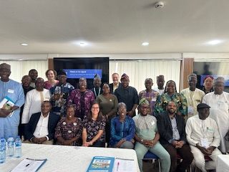 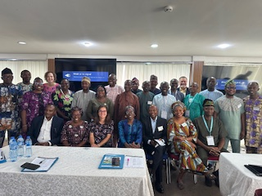

Image 1: Key Partners of the PSEG and Kaduna State Reps Image 2: Key partners of the PSEG and Federal Government reps

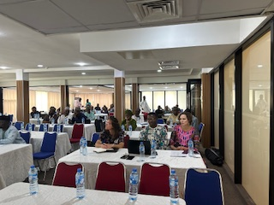 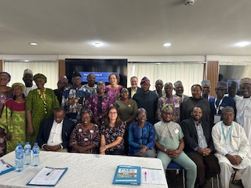

Image 3: Stakeholder meeting session Image 4: Key partners with

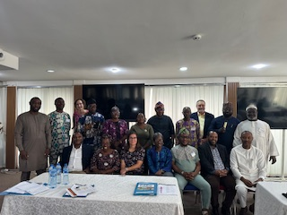 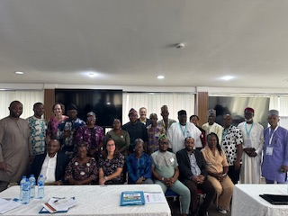

Image 5: Key Partners with the Abuja support team Image 6: Key partners with Farmer Groups

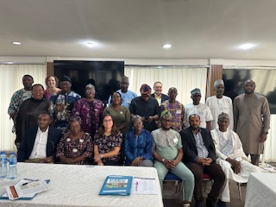 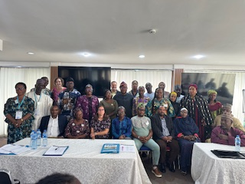

Image 7: Key Partners of the PSEG Image 8: Key partners with

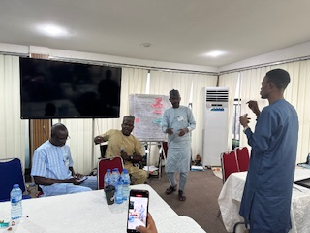 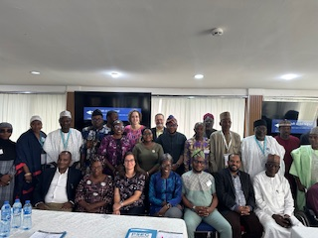

Image 9: JONAPWD making their presentation Image 10: Key partners with

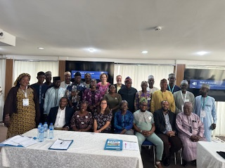 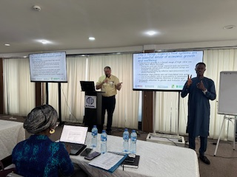

Image 11: Key partners with Image 11: CoP making his recap of Day 1

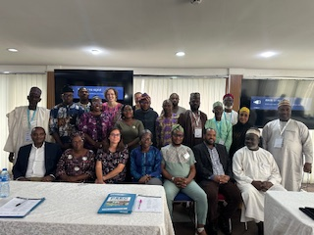

Image 12: Key partners with